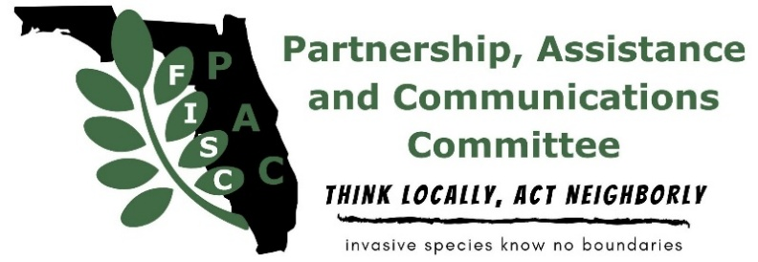

Florida Invasive Species Council’s Partnership, Assistance and Communications Committee’s (FISC-PAC)
Cooperative Invasive Species Management Area Grant Application
2026-2027

Program Description
The intent of this grant program is to provide funding to Florida’s Cooperative Invasive Species Management Areas (CISMAs) who will advance the FISC-PAC mission through partnership led efforts (e.g. public events, workshops, workdays, outreach, etc.), which focus on invasive species and their impacts on the natural areas and/or the economy of Florida. Proposals will be accepted from all Florida CISMAs as shown: https://www.floridainvasives.org/cismas.cfm. The FISC CISMA Grant Committee will review all applications. Winners for 2026-27 will be announced in June 2026 and will have 12 months to complete the project (through June 2027). Winning CISMAs must present a summary of results via poster or oral presentation at the next FISC Conference and provide a summary article or PDF file of any final product (brochure, sign, etc.). Results may also be used in the FISC quarterly newsletter.

Evaluation Criteria
Award preference will be given to proposals that meet the following criteria:
- Involve durable supplies for in-person outreach, as listed in the table below. Applicants requesting these supplies should document the number and name of the events their CISMA has tabled at over the last two years.
- Involve plants listed as Category I or II species on the FISC 2025 List of Invasive Plant Species, found on www.floridainvasives.org/plant-list/, non-native wildlife found on https://myfwc.com/wildlifehabitats/nonnatives/species-not-native-to-florida/, or species that have been designated as Early Detection/Rapid Response (EDRR) priority species by the CISMA (EDRR lists can be found on each CISMA’s webpage).
- Each application must include a document of support from the CISMA. Examples of support include, but are not limited to: letter signed by CISMA chair; minutes of membership meeting or steering committee meeting that document the decision to support proposed project, etc.
- Provide a brief statement as to how the proposed project advances the FISC mission: “to support management of invasive plants in Florida natural areas by providing a forum for the exchange of scientific and technical information.”
- Provide a brief statement as to how the proposed project advances the FISC-PAC mission: “to improve the efficiency and effectiveness of partnership approaches to preventing and controlling invasives species through increased communication, coordination and shared resources in order to protect wildlife habitat, working lands, natural communities and biodiversity in Florida.”
- Include an evaluation process of the project that will clearly demonstrate success or failure.
- Include a detailed timeline of grant activities.

Each CISMA can submit only one proposal per year. Grants may not be used to fund overhead costs. All necessary permits are the sole responsibility of the applicant or organization. For 2026, FISC has a total of $1,500.00 available. Requests for funding should not exceed $1,500.00 and all funds awarded are to be used within 12 months of receipt. If full funding is not available, partial funding may be awarded. For proposals involving outreach supplies, the CISMA will be responsible for procuring the items (assistance finding vendors can be provided if needed), up to the allowable amount below and will be reimbursed at cost. For proposals that include printed material (brochure, sign, etc.), applicants must submit a rough draft for FISC CISMA Grant Committee approval and a sample of previously published work. Alternatively, applicants may submit a draft within 3 months of award notification, with funds provided after the draft is accepted by the FISC CISMA Grant Committee. The FISC CISMA Grant Committee reserves the right to review all publications resulting from this funding, prior to printing and distribution.

Item Description | Potential Vendors | Maximum Allowable Amount
Tier 1
Banner and/or tablecloth with CISMA logo | Local printer | $100 each
Display board | Most online vendors or big box stores | $200
Easel | Most online vendors or big box stores | $50
Tier 2
Pop up tent (up to 10 x 10) | Most online vendors or big box stores | $175
Table | Most online vendors or big box stores | $75
Small, branded giveaway items (specific items must be approved by committee before purchase) | Online suppliers | $200

Instructions
Use the headings on the following page as a template for your grant application. Insert tables or images if appropriate. Use as much detail as possible. If your proposal includes signs, brochures or web pages, please include at least a partial sample of previous work or a proposed mock-up. Applications that are incomplete will receive lower ranks. The length of the entire application (beginning on the next page), not including attachments, should not exceed 5 pages. For questions concerning this application, contact Collin MacGibeny at cisma_grant_chair@floridainvasives.org. E-mail completed application as a *.PDF or *.DOC file.

Deadline for proposal submission is 5:00pm (EST) Friday, May 29, 2026. Applications received after this time will not be considered.

FISC-PAC’s 2025-2026 Cooperative Invasive Species Management Area (CISMA) Grant

Applicant Information

Florida CISMA:
Contact Person:
Job Title:
Agency/Organization to whom the award check should be made payable:
Address:
Phone:
Email:

Project Description

- Project title:

- Project summary:

- What are the FISC, non-native wildlife, and/or CISMA EDRR target species?

- What is your method of implementation?

- Where will the project be located? If applicable, include the county and city name and more specific directions. Applicants may provide a letter of support from the landowner, if applicable.

- How will your proposed project benefit the CISMA?

- How will your proposed project advance the FISC mission?

- How will your proposed project advance the FISP mission?

- Describe in detail how you will evaluate the effectiveness of your proposed project.

- Describe prior activities that may help you to accomplish this project, if applicable.

- What is your timeline for completion?

- Project budget. Indicate a breakdown of uses for your requested funds (maximum $1,500). You may supply this information in tabular format if desired. The FISC CISMA Grant does not fund overhead.

- Will you/your CISMA commit to providing feedback to the FISC community via a written submission for the FISC website, FISC quarterly newsletter, or a presentation (oral or poster) at the FISC annual symposium? Will you also commit to providing a PDF file of any written products of the grant?

- If you have been awarded a FISC CISMA Grant in the past, have you completed the required article or conducted a presentation at the FISC Conference?

- The following are additional questions for proposals that will have a physical or digital product such as a sign, brochure, booklet, poster, video, or smartphone app. In answering, please try to closely approximate what your final product will be like.
- Provide physical details about the finished product (length/binding/size/accessibility/etc).
- Have you researched your proposed project to be sure it does not already exist elsewhere? How will your product be different from others that may already be available through UF/IFAS Extension, other CISMAs, county governments, or other organizations?
- If you are modeling your product after previous work by your CISMA or another CISMA, what is that “model product?” Provide a URL if applicable.
- Describe any expertise you or your CISMA may have that will help you to create a quality product.

Send completed application to cisma_grant_chair@floridainvasives.org by 5pm Fri, May 29, 2026.

